WEB front-end programming report

Detailed Design

|  |  |
| --- | --- |
| Project Name | Responsive design questionnaire survey program |

|  |  |
| --- | --- |
| Name | Task |
| Yiwen Li | The whole task |

目录

1.Overview 1

2.Reference 1

3. Project Design 2

3.1 Front desk homepage design 2

3.1.1 Administrator registration, login 2

3.1.2 Interface design 2

3.1.3 Main HTML Code 2

3.1.4 CSS code used 3

3.2 Administrator adds title page design 3

3.2.1 Interface design 3

3.2.3 Main HTML Code 3

3.2.4 CSS Code 4

3.3 Administrator management topic page design 4

Administrator management topic page design 4

3.3.1 Admin delete question 4

3.3.2 Interface Design 4

3.3.3 Main HTML code 4

3.3.4 CSS code used 5

3.4 Survey page design 6

3.4.1 The user answers the questionnaire 6

3.4.2 Interface design 6

3.4.3 Main HTML code 7

3.4.4 CSS code used 7

3.5 Design of the answer statistics page 7

3.5.1 The administrator checks the answer 7

3.5.2 Interface design 8

3.5.3 Main HTML code 8

3.5.4 CSS Code 8

Responsive design of the questionnaire survey program

Design and implementation detailed design report

# 1.Overview

The responsive design questionnaire survey system allows a basic user information to register an account, and log in to the questionnaire survey system through the user's identity to answer questions in the system.

Users can perform basic account operations, including setting account names, account passwords, and answering. The user has a main interface to perform these operations.

At the same time, the system allows the respondent to also register an administrator account. After logging in, you can add, delete, modify, and query the questionnaire answers.

# 2.Reference

1. WEB前端设计基础，张树明，清华大学出版社，2014
2. CSS权威指南第三版, Jeremy Keith
3. JavaScript高效图形编程，Nicholas C. Zakas
4. JavaScript权威指南第六版，David Flanagan
5. JQuery网页开发实例精简，黄格力

# 3. Project Design

## 3.1 Front desk homepage design

### 3.1.1 Administrator registration, login

Administrator registration, login

### 3.1.2 Interface design

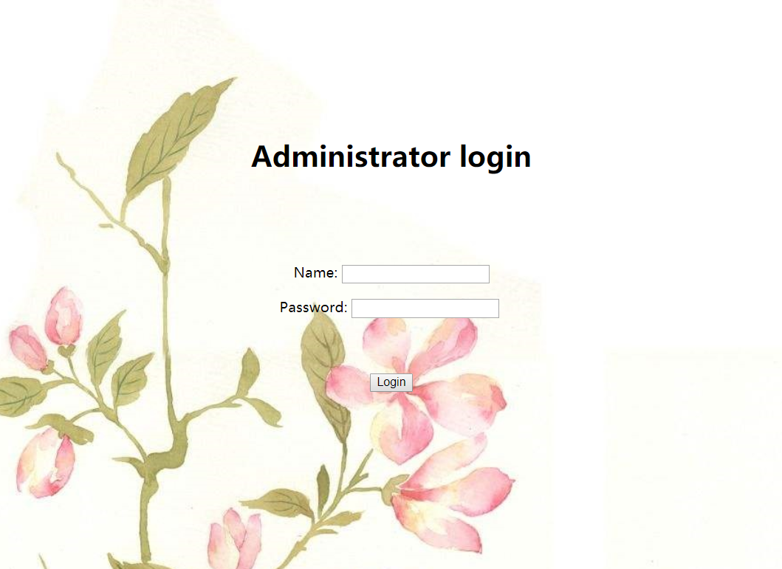

### 3.1.3 Main HTML Code

<div width:500px height:400px>

<p class=*"row"*>

<label for=*"first-name"*>Name: </label>

<input type=*"text"* id=*"name"* name=*"name"* class=*"field-large"*/>

</p>

<p class=*"row"*>

<label for=*"password"*>Password:</label>

<input type=*"password"* id=*"password"* name=*"password"* />

<br><br><br><br>

<input type=*"submit"* value=*"Login"* class=*"btn"*>

</p>

</div>

### 3.1.4 CSS code used

style="background: url(src/flower.jpg)

## 3.2 Administrator adds title page design

### 3.2.1 Interface design

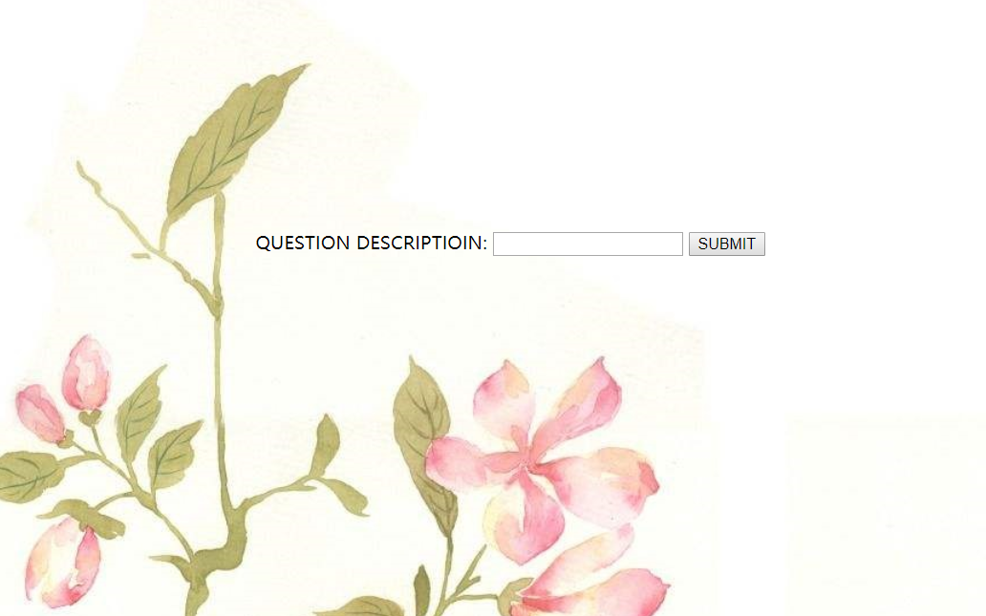

### 3.2.3 Main HTML Code

<div>

<center>

<br><br><br><br><br><br><br><br><br><br>

<form action=*"insertsuccess.jsp"*>

<p>QUESTION DESCRIPTIOIN:

<input type=*"text"* cols=*"30"* rows=*"3"* name=*"question"*> <input type=*"submit"* value=*"SUBMIT"*></p>

</form>

</center>

</div>

### 3.2.4 CSS Code

style="background: url(src/flower.jpg)

## 3.3 Administrator management topic page design

## Administrator management topic page design

### 3.3.1 Admin delete question

The administrator deletes the existing questions in the database

### 3.3.2 Interface Design

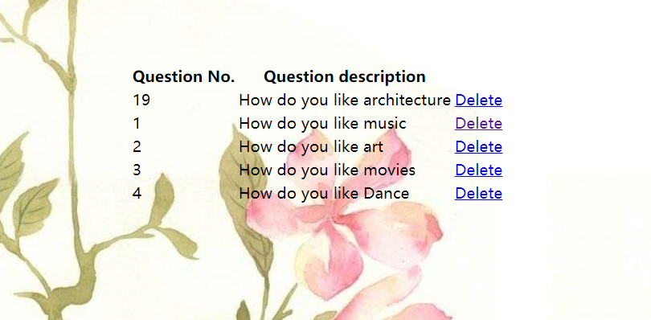

### 3.3.3 Main HTML code

|  |  |
| --- | --- |
| <!DOCTYPE HTML PUBLIC "-//W3C//DTD HTML 4.01 Transitional//EN"> | |
|  | | <html> | | |
| <head> | | | |
| <base href="http://localhost:8080/questionnaire/"> | | | |
|  | | | |
| <title>Question Management</title> | | | |
| <meta http-equiv="pragma" content="no-cache"> | | | |
| <meta http-equiv="cache-control" content="no-cache"> | | | |
| <meta http-equiv="expires" content="0"> | | | |
| <metahttp-equiv="keywords" content="keyword1,keyword2,keyword3"> | | | |
| <meta http-equiv="description" content="This is my page"> | | | |
|  | | | |
| </head> | | | |
| <body style="background: url(src/flower.jpg)"> | | | |
| <br><br><br><br><br><br><br><br><br><br><br><br><br> | | | |
|  | | | |
| <tr width=900px><center><div width:100% height:100% ><table border=0><th>Question No. </th><th>Question description </th></tr><tr><td>1</td><td>How do you like music</td> | | | |
| <td><a href="delete.jsp?questionid=1" >Delete</a></td> | | | |
|  | | | |
| </tr><tr><td>2</td><td> How do you like art</td> | | | |
| <td><a href="delete.jsp?questionid=2" >Delete</a></td> | | | |
|  | |  | | |
| </tr><tr><td>3</td><td>How do you like movies?</td> | | |
| <td><a href="delete.jsp?questionid=3" >Delete</a></td> | | |
|  | | |
| </tr><tr><td>4</td><td>How do you like Dance?</td> | | |
| <td><a href="delete.jsp?questionid=4" >Delete</a></td> | | |
|  | | |
| </tr><tr><td>5</td><td>How do you like architecture?</td> | | |
| <td><a href="delete.jsp?questionid=5" >Delete</a></td> | | |
|  | | |
| </tr></table></div></center> | | |
| <center>  <a href="addquestion.jsp" src></a></center> |
| </body> |
| </html> |

### 3.3.4 CSS code used

style="background: url(src/flower.jpg)

## 3.4 Survey page design

### 3.4.1 The user answers the questionnaire

The user enters the survey interface after logging in

### 3.4.2 Interface design

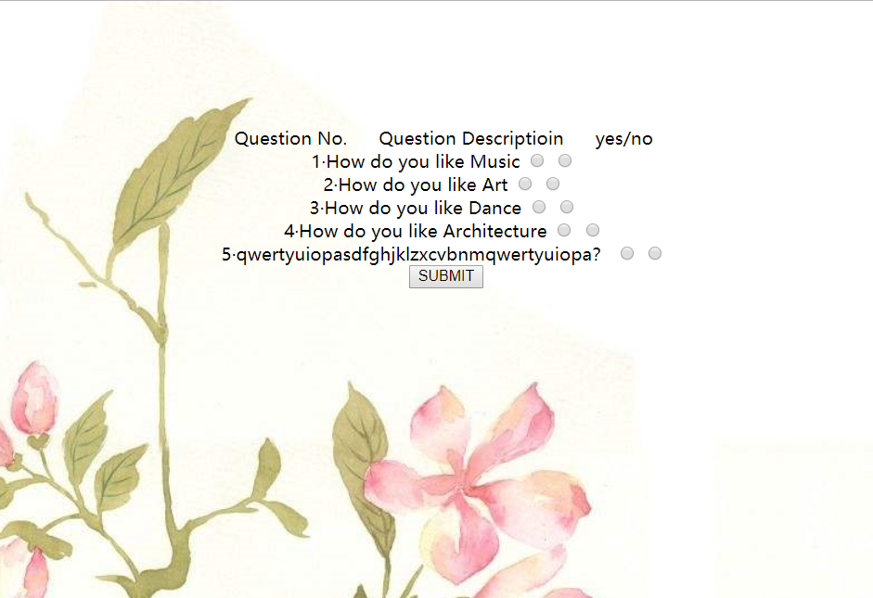

### 3.4.3 Main HTML code

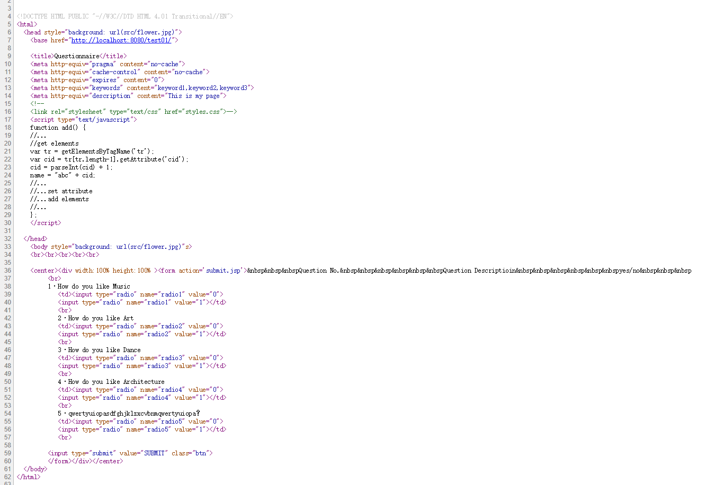

### 3.4.4 CSS code used

style="background: url(src/flower.jpg)

## 3.5 Design of the answer statistics page

### 3.5.1 The administrator checks the answer

The administrator can view the statistics of the questionnaire answers on the admin side

### 3.5.2 Interface design

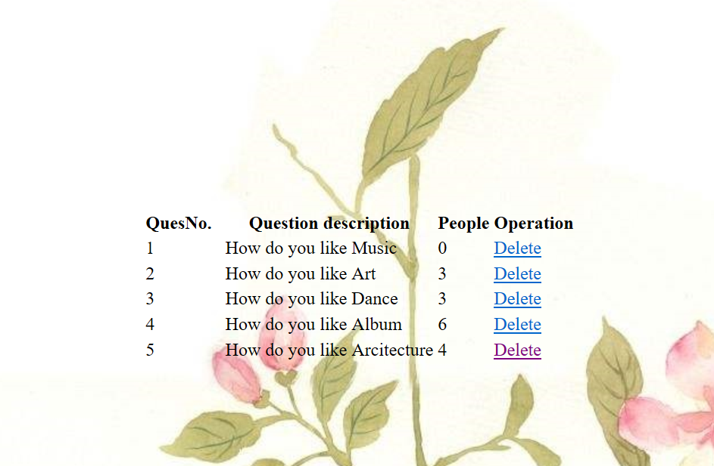

### 3.5.3 Main HTML code

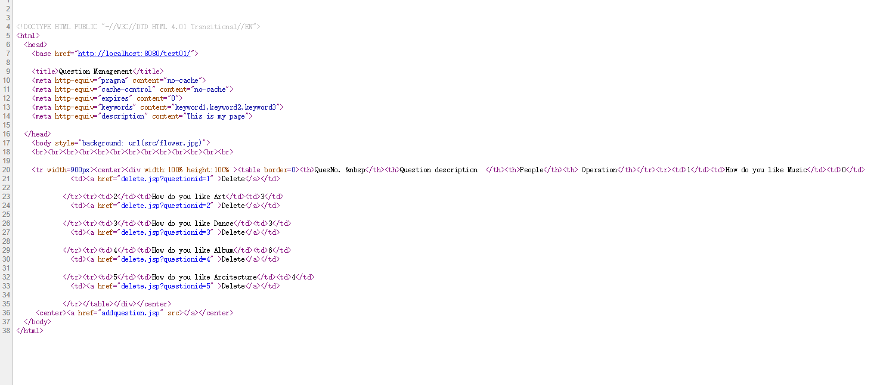

### 3.5.4 CSS Code

style="background: url(src/flower.jpg)